Greta Gage

11/15/17

WRIT 4662W

**DITA Assignment Architecture Documentation**

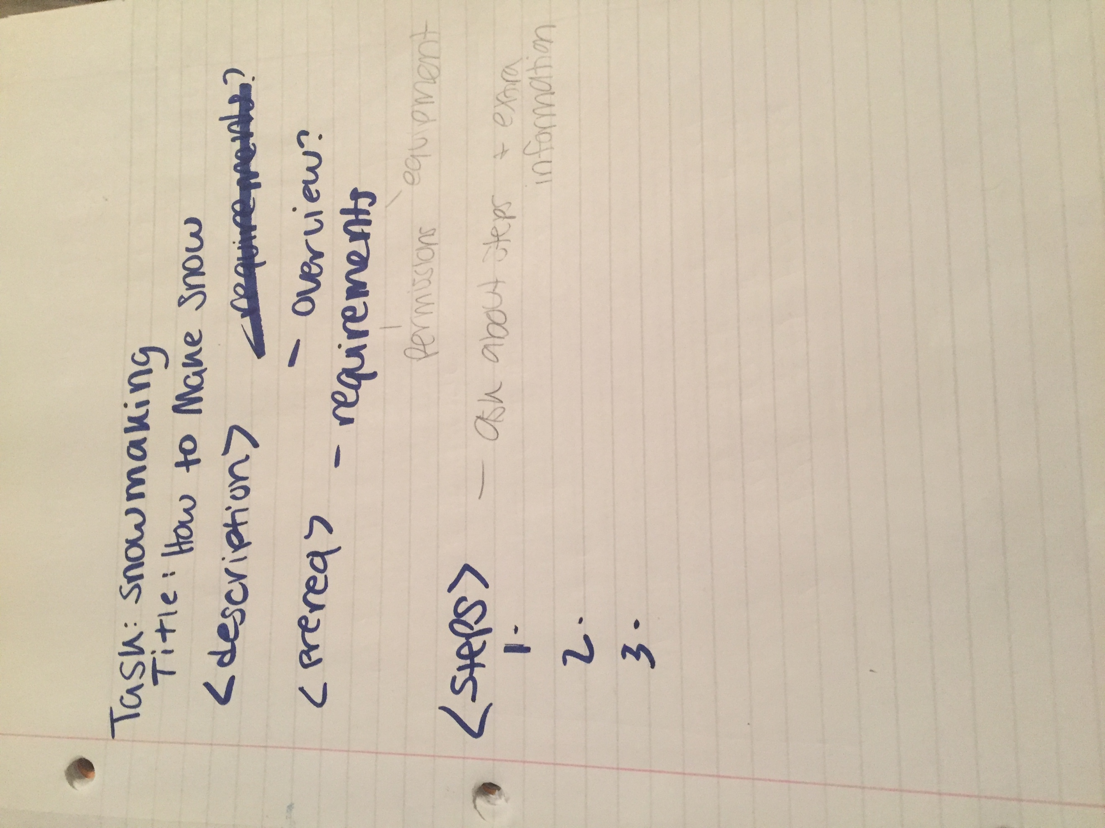

Once I found the resource that worked best for me I started by doing a very rough sketch of what I wanted my task to look like and which tags I wanted to use. Knowing that this document would be used by a lot of volunteers for the Edina Nordic Ski Team (and people outside of the ski team with different equipment) I wanted to make sure I was minimalistic with the amount of words used, but still keeping things clear. To do this I made sure I was using bullet points, numbered lists, bolded text, and italicized text.

During the earliest building phases of my DITA documents, I looked at the table that breaks down DITA documents into a selection of questions provided in *DITA Best Practices*. I didn’t create a separate document to work through this process because I continued to return to this table as an editing tool for the XML. Figuring out the steps for making snow was a big piece of this process because until this project, I had never seen a step by step instruction manual for snowmaking. Some of the key questions I used were: what is the goal? What tasks does the user need to perform to accomplish the goal? And who performs the task?

Because I didn’t know the exact steps for making snow, I got in contact with one of the Edina Nordic Coaches and asked for snowmaking steps. Their feedback was helpful, but it wasn’t delivered very orderly. Essentially, they gave me all the information I needed but they were mixing extra details and substeps in with the major steps. To work around this issue, I had to piece through their thread of text message to pick out the critical details and then write those steps in the Oxygen XML Editor. After that, I went back through the messages to see what details were broad enough to apply to an audience outside of the Edina Nordic Ski Team. Some of those details became substeps and some became “extra information” that didn’t merit their own bullet but needed to be mentioned with the step. After I was content with what I had, I sent screenshots of my work in DITA to the coach I was already speaking with and asked if they liked what I had. They provided feedback, and some of it didn’t quite fit well with DITA’s single topic formatting so I adapted those pieces to something that would work within the program.

After the peer review on this assignment, I realized I misunderstood how narrow the definition of “topic” is in the realm of DITA. I split the one DITA document into 3 different documents. One was for the title and description, the second focused on prerequisites, and the third was the actual steps of the process.